Morgan State Routs Virginia-Lynchburg in Home Opener, 61-0
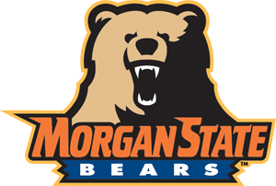
By: Devon Ashby

Just like last season, the Morgan State University Bears entered their first home game of the season with a record of 0-2, and just like last season, they ended the game in victorious fashion, earning their first victory of the season.
The Bears beat the Dragons of the University of Virginia-Lynchburg by a score of 61-0 at Hughes Memorial Stadium Saturday afternoon. It was a dominant performance for the Bears.
The game started with a 69-yard touchdown pass from quarterback Moses Skillon to receiver/running back Ricky Fisk. The Bears’ safety Fonya Agenda then intercepted a pass and took it to the 33-yard line of Virginia-Lynchburg, and set up the offense and Fisk for a 24-yard rushing touchdown. The Bears would go on to score 37 points in the first quarter, including three more touchdown passes from Skillen to his other receiver, Andrew King, and a safety by linebacker Brandon Griffith and the Bears special teams unit.
The Bears defense was aggressive and physical the whole game. In the second half, the defense gave up some big plays, but they held the Dragons out of the endzone, including a big goal line stand on 4th down at the end of the game.
After the game, Coach Lee Hull said he was pleased with his team’s performance, saying, “I think we played well. Our big thing this week was that we focus and we play intense and I think that we did that.” He also said that he would’ve liked for the offense to do a little more in the second half and that they “bogged down,” and he mentioned that the defense let up in the second half and gave up a few big plays but he “liked how they held on 4th & goal” on the Dragon’s final offensive series.
The Bears now look for their second win of the season as they take on the Howard University Bison in Chicago for the Chicago Football Classic.

